**Abstract**

Wildlife crossing structures paired with exclusion fencing have proven to successfully reduce animal vehicles collisions while still allowing for connectivity across roadways. Managing animal mortality and subpopulation connectivity is crucial to successful species and landscape stewardship. Highway mitigation projects are large economic investments that remain on the landscape for many decades, so governments and planning agents strive to balance cost and benefit and build cost-effective structures with the greatest positive impact on local wildlife. Ideal dimensions of overpasses and underpasses vary by species, but scientists generally suggest that overpasses are about 50 meters wide. Optimal width can also depend on structure length, with longer structures requiring additional width, leading experts to suggest a width to length ratio of 0.8. We sought to assess how these recommendations manifested in practice—where agencies use this information to design structures and build structures while also balancing costs and logistical challenges—and the degree to which built structures conform to current recommendations. Internationally, countless wildlife crossings have been constructed to reduce the negative impacts of roadways that bisect landscapes. Using a novel measurement technique, we analyzed 120 overpasses located in North America, Europe, Asia, and Oceania. The average width of the wildlife overpasses was 34 m. The majority of wildlife overpasses located in North American and Europe failed to meet their respective dimensional expert guidelines. We investigate reasons explaining the non-compliance and provide recommendations for future overpass designs. For a sample of overpasses, we also found a non-significant relationship between taxa-specific (black bears (*Ursus americanus),* grizzly bears *(Ursus arctos),*wolves *(Canis lupus)*, coyote *(Canis latrans),* cougars *(Puma concolor),* deer *(Odocoileus sp.)*, elk *(Cervus elaphus)*, moose (*Alces alces) and,* Bighorn Sheep *(Ovis canadensis)*) crossing rates and the width, width:length of 12 overpasses located in western North America. In reviewing various overpass effectiveness and cost-effectiveness studies from around the world, we conclude that wide overpasses (~50m) continue to present important, cost effective solutions in decreasing the barrier effective of the road (especially when targeting width sensitive species and large assemblages of mammals). Future studies, however, are encouraged to further explore the specific instances when underpasses and narrower overpasses present more cost-effective ecological solutions.

**Keywords:** Highway, wildlife, crossing structure, overpass, effectiveness, guidelines

1. **Introduction**

**1.1 Background**

Roads provide essential connection corridors for people and goods across the world but can be challenging features for wildlife to cross safely and have myriad environmental consequences (Forman & Alexander, 1998). Decades of research has shown that roads can degrade and fragment habitat, create barriers to animal movement, and can be a major source of animal mortality (*reviewed by* Fahrig & Rytwinski, 2009; Trombulak & Frissell, 2000). With naturally low population densities and large home ranges, large mammal populations are especially vulnerable to the potentially exacerbating threats of wildlife vehicle collisions (WVCs) resulting in mortality (Gunson & Clevenger, 2003; Kusak, 2000) and the genetic isolation of sub-populations on either side of the road (Riley et al., 2006; Sawaya et al., 2019). Creative solutions to combat these threats are needed, especially on highways where traffic volumes are high and collisions are especially dangerous for wildlife and people.

A solution that is gaining in popularity is the construction of wildlife crossing structures (Sijtsma et al., 2020). When paired with wildlife exclusion fencing, wildlife crossing structures reduce wildlife mortality from WVCs (*reviewed by* Huijser et al., 2009) while still promoting demographic and genetic connectivity for wildlife across the road (Sawaya et al., 2013; Sawaya et al., 2014). These structures are often met with little to no public resistance because they provide added benefits to motorists (e.g., increased safety and reduced costs related to WVCs) without altering the flow of traffic (*reviewed by* Huijser et al., 2009; Sijtsma et al., 2020). When wildlife crossing structures are paired with adequate wildlife fencing, studies have found an approximate 86% decrease in reported WVCs (Huijser et al.,2009). For example, in Banff National Park, a series of crossing structures and fencing along a 23 km section of the Trans-Canada Highway reduced wildlife collisions by 80%, and reduced collisions with common species such as deer and elk by 96% (Clevenger et al., 2001).

**1.2 Overpass versus Underpass**

Wildlife crossing structures can be subdivided into two classes: underpasses and overpasses, which respectively allow wildlife to cross under or over the roadway (Clevenger & Huijser, 2011). Clevenger & Huijser (2011) suggest that large wildlife overpasses are an optimal crossing structure choice for the greatest diversity of species. Furthermore, various studies have shown that carnivores and ungulates (e.g., grizzly bears, moose, wolves, deer, elk, pronghorn, and desert bighorn sheep) prefer large, open overpasses compared to more constricted underpasses (Clevenger & Waltho, 2005; Kusak et al., 2009; Sawyer et al.,2016). Ultimately, however, various abiotic and biotic factors influence the use and effectiveness of a crossing structure (Clevenger & Waltho, 2000; Clevenger & Waltho, 2005; Barrueto et al., 2014; Seo et al., 2021). Consequently, a universal species-specific preference for overpasses versus underpasses can be difficult if not impossible to clearly establish. For example, Simpson et al. (2016) found a migratory mule deer preference for overpasses in Nevada, U.S.A., whereas Sawyer et al. (2016) present the opposite, finding a migratory mule deer preference for underpasses in Wyoming, U.SA. Similarly, while many large mammals in Banff National Park exhibited a preference for overpasses, Gloyne and Clevenger (2001), found a clear cougar preference for underpasses. Based in part on various species-specific crossing structure preferences, many highway wildlife crossing structure projects employ both structure types along the length of a project, promoting permeability for the greatest number of species (Clevenger & Waltho, 2000; Clevenger & Waltho, 2005; Cramer, 2012).

**1.3 Overpass Width**

Among many considerations when designing a crossing structure (e.g. location and adjacent land use), one important aspect is the structural dimensions of the structure. For the purposes of this study, we define wildlife overpasses as above-grade structures that cross over roads and/or other transportation infrastructure. Similar terms used in literature to describe overpasses include landscape bridges, green bridges and eco-ducts. In comparison to wildlife underpasses, overpasses are preferred by most large mammals (Kusak et al., 2009; Sawyer et al.,2016), but often also cost significantly more (McGuire & Morrall, 2000).

Overpass width is an important design consideration. Studies that have compared overpass effectiveness data with overpass width suggest that wider overpasses more effectively enable the crossing of large mammals opposed to narrow structures that may deter crossings if animals feel uncomfortable and hesitant to cross (Pfister et al., 1997; Clevenger & Waltho, 2005). However, wildlife overpasses are costly structures, often 5-15 million dollars USD and wider structures cost more than narrower ones. Transportation agencies thus attempt to build structures whose dimensions satisfy the ecological role the structures are designed to support while delivering the project in a cost-effective manner. While the ideal width of a wildlife overpass will depend upon various factors (e.g. project objectives, target species, location etc.), in North America the recommended highway overpass structures width is 50-70 m over four lane highways. Overpass widths should also consider the length of the structure, where longer structures require additional width. This consideration is addressed by the recommendation of a width to length ratio >0.8 for overpasses (Iuell, B. (ed.)., 2003).

These recommendations are supported by research that suggests that some large mammals prefer to cross an overpass that is at least 50 m wide. Using wildlife crossings rates and demographic analysis, Ford et al. (2017) suggest that in comparison to underpasses, large overpasses (>50m in width) serve as crucial passages for family units of the grizzly bears whose survival is crucial to population viability. Also, in Banff National Park, the crossing rates of various large mammals were positively linked to structure width, and negatively associated with structure length (Clevenger & Waltho, 2005). Similar evidence from (Pfister et al., 1997) shows that crossing structures in Europe that were less than 20m were used significantly less than wider structures, and that between 20m and 50m the crossing rate of wildlife increased and subsequently flattened out.

In practice, countless factors (e.g. political interest, budget, government structure) other than expert recommendations ultimately influence the width of overpass structures (Woo et al., 2018). In South Korea for example, researchers found that some of the technical parameters of crossing structures (e.g. underpass height, underpass openness ratio) often fail to comply with expert recommendations (Woo et al., 2018). To further investigate overpass dimensions and their adherence to expert guidelines, our study created a global inventory of wildlife overpasses and compared their physical characteristics to various expert recommendations/guidelines.

**1.4 Crossing Structure Effectiveness**

To properly assess the effectiveness of a wildlife crossing structure, the ecological role of wildlife structures must first be defined (Clevenger, 2005). While ambitious, the goal of highway mitigation programs should be to decrease the negative ecological effects of the roadway, improve wildlife population viability, and support the viability of local wildlife populations (Van der Grift et al., 2013). However, studies that directly demonstrate wildlife crossing structures increase the population viability of wildlife are scarce and have not been performed for large terrestrial mammals (van der Reeet al.,2007; van der Ree et al.,2009). Changes in population viability are difficult to measure/model (van der Grift et al.,2013); so many studies instead rely upon two related metrics of wildlife crossings structure success: namely, the surrounding reduction of wildlife mortality as a result of fencing that excludes wildlife from collisions on the roadway (Huijser et al., 2009; 2016, Rytwinski et al.*,* 2016) and, the ability of the structure to promote roadway permeability and dispersal between subpopulations on either side of the road (i.e., successful crossings, Kusak et al.,2009; McKinney & Smith, 2007; Sawaya et al.,2013; Sawaya et al., 2014).

For the purposes of this study, we concentrate on the ability of the wildlife overpasses to reduce the barrier effect of the road through movement over the roadway. While other studies have measured overpass effectiveness in terms of demographic and genetic connectivity (Sawaya et al., 2013, Sawaya et al., 2014; Ford et al., 2017) or percent of successful crossings (Dennebom et al., 2021), our study amasses wildlife crossing rates for wildlife overpasses in western North America. Wildlife crossing rates are the most commonly used wildlife overpass effectiveness metric (Van der Grift et al., 2013) and provide evidence of road way permeability and overpass use, although can be be difficult to compare between areas with differing abundance of wildlife. Consequently, we sought to answer the following questions 1) can we gather sufficient crossing data from state and provincial agencies to crossing rates in relation to to overpass dimensions? and, 2) building off the results from this review and lessons learned in analysing the crossing data, can we recommend sampling designs that could help measure structure effectiveness in the future? Road agencies are increasingly in need of evidence to support the design and construction of wildlife overpasses.

Ultimately, this study is designed to help inform road ecologists and transportation agencies as they design wildlife overpasses. First, we created a global inventory of wildlife overpasses to understand how wide overpasses have been built, and to what extent these widths adhere to expert guidelines. Next, we performed an analysis of overpass effectiveness in relation to width for various structures in northwestern North America. In summarizing overpass widths, guideline compliance, and performance, we present the current evidence for the optimal width of wildlife overpasses and suggest a robust monitoring approach to assess their effectiveness in the future.

**2.0 Methods**

**2.1 Literature Review and Identifying Overpasses**

A literature review was conducted to locate and identify overpasses worldwide and measure their structural dimensions. Keywords included “wildlife overpass”, “eco-duct”, “green bridge”, and “wildlife crossing structure”. The search engines Google and Google Scholar were used to collect pertinent peer-reviewed literature, government reports, websites, and overpass locations. Further consultation with various experts in the field supplemented the inventory with additional structures. Supporting information from the variety of sources used to locate the structures in Google Earth Pro 7.3.4.8573 (64-bit). Overpasses were included in the review if they were visible on Google Earth Pro, if sufficient supporting information was available in order to locate the structures, and if the structure appeared to be built for use by wildlife. Multi-use overpasses, as described in Clevenger & Huijser (2011), (e.g. overpasses visibly paved with asphalt) were not included in the inventory. Landscape bridges (overpass structures >80m wide) that emphasize habitat connectivity and restoration at a larger scale were also excluded from the review (Iuell, B. (ed.)., 2003). To explore the relationship between overpass dimensions and wildlife crossing rates, species-specific wildlife crossing data was also collected from literature and government reports for a sub-sample of 12 overpasses located in western North America. Appropriate transportation professionals were contacted to obtain overpass dimensions and crossing data when not readily available in the literature.

**2.2 Measuring Dimensions**

Overpasses can vary greatly in size, shape and design (Iuell, B. (ed.)., 2003; Solowczuk, 2020). For the purposes of accurate comparison between different structures, we developed overpass dimensional definitions for all measurements made in Google Earth Pro. If the aerial image quality was sufficient and the view was unobstructed the estimated width(s) and length(s) were measured in Google Earth Pro. Reported dimensions were also recorded from available literature or government reports. Government agencies and reports often only reported a width and length and often lacked supporting information that explained how the structural dimensions were obtained. While the width of the overpass is often clearly visible from aerial imagery, the length can be difficult to distinguish especially with older overpasses where plant communities have extensively colonized on and around the structure. In Google Earth Pro, we estimated three overpass lengths measurements: the width of roadway below (including median and lanes of traffic), the length of the overpass headwall, and the length of the overpass including visible ramps. We recorded two width measurements: the inner edge to edge width between opposite headwalls or fencing, and the outer edge to edge width between opposite headwalls. All measurements are clearly illustrated in Figure 1. In accordance with recommendations made by Iuell et al.,(2003), we define our primary overpass width as the inner width of wildlife overpass structures. Likewise, we define the overpass length as the headwall length because it is a consistent, representative length metric amongst the majority of overpasses, and is easily viewed in aerial imagery.

Harrington et al. (2017) compared Google Earth Pro path measurements to physical measurements of road features and found evidence to support the use of Google Earth Pro as a scientific measurement tool. We also tested the accuracy of the path tool on objects of known length, 91.44 meter (100 yard) long football fields, to assess reliability. Across 20 NFL and NCAA football fields, we found an average error rate of 0.2% (see Appendix A). Because elevation change along structures is minimal it was assumed to have a negligible effect on measurement.

**~~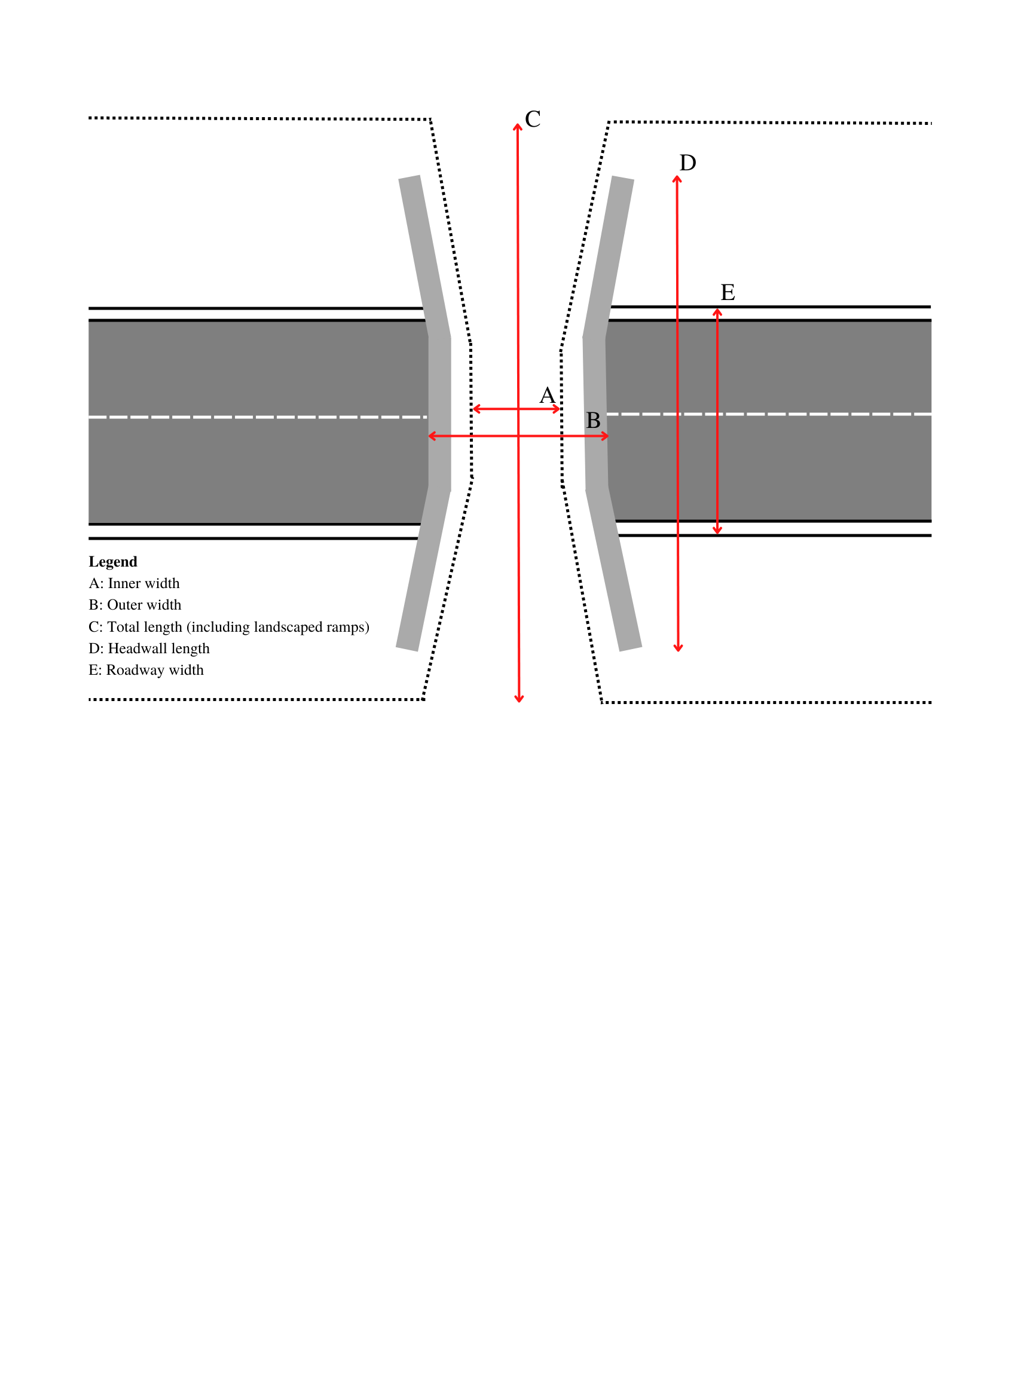~~**

**Figure 1:** Graphical representation of the measurement procedure for all overpass dimensions obtained in Google Earth Pro 7.3.4.8573 (64-bit).

**2.3 Overpass Crossing Rates**

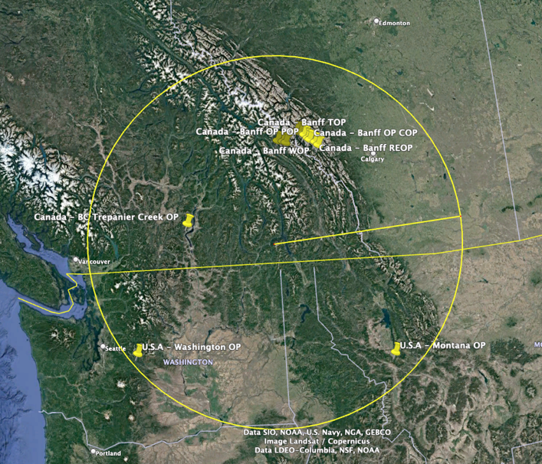

**Figure 2.** Location of the twelve wildlife overpasses included in overpass effectiveness analysis.

We assessed the wildlife crossings effectiveness of twelve overpasses approximately located within a 500 km radius circle in northwestern North America, inclusive of British Columbia (Canada) Alberta (Canada), Montana (U.S.A.), and Washington (U.S.A). All twelve overpasses were built for use by large mammals in montane ecoregions. Using multiple camera traps (minimum two) each monitoring project recorded the number of successful passages across the overpass for a variety of ungulate and carnivore species (minimum of 164 monitoring days and maximum of 3180 monitoring days). We gathered data for ten large mammal species commonly found in the montane ecoregion of western North America: elk, moose, deer sp. (mule and white tailed), big-horned sheep, black bear, grizzly bear, cougar, coyote, and wolf. Similar to Ford et al.(2017), we evaluated the species-specific number of successful crossings per monitoring day to develop a metric that could be compared between structures. Subsequently, a taxa-specific, and total crossings regression was performed for all twelve structures in relation to their inner width and inner width:headwall length ratio as estimated from Google Earth Pro. We did not have information on relative abundance of each species around each structure which we acknowledge limits the inferential power of this approach.

**3.0 Results**

We identified 120 individual wildlife overpasses across the world (Figure 3). The majority of the 120 wildlife overpasses were concentrated in northern latitudes (n=73) (Latitude >40°) and OECD nations such as Canada (n=12) United States (n=16), Germany (n = 11), Holland (n=24) and South Korea (n=35).

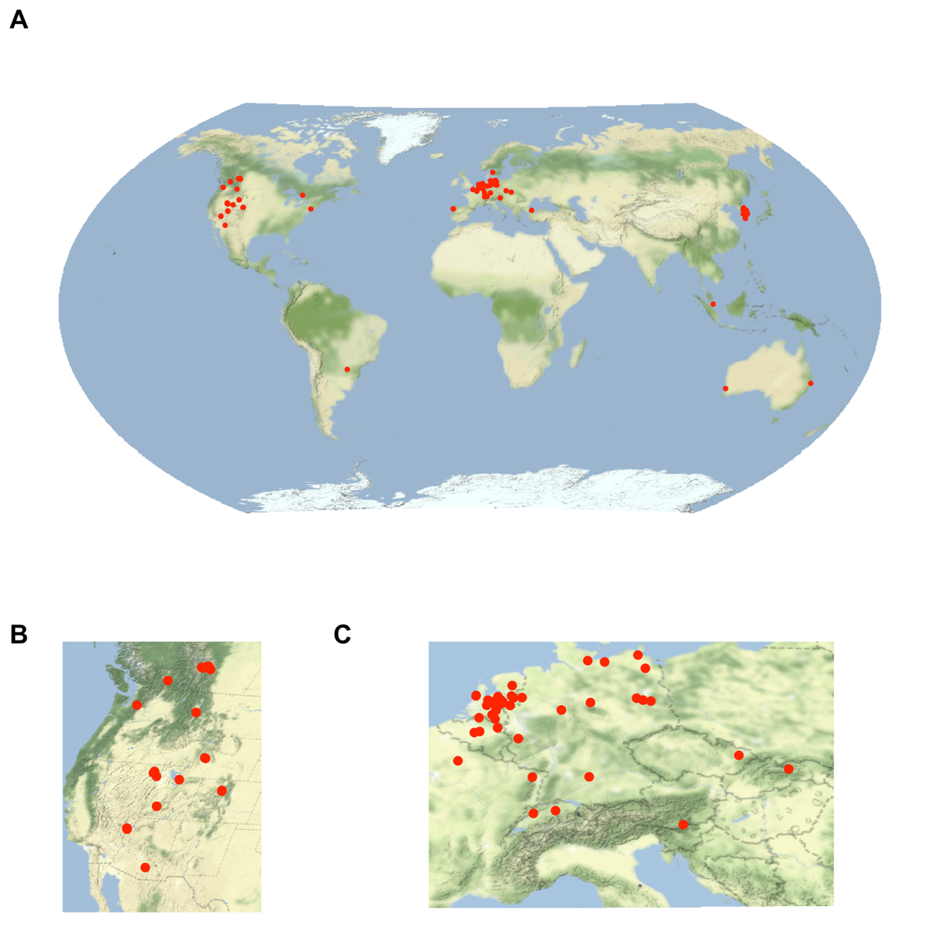

**Figure 3** A) Map of the 120 wildlife overpasses found in the literature review. Clusters of overpasses were found in B) western North America, and C) Europe and eastern Asia.

**Table 1:** Mean overpass parameters measured in Google Earth Pro 7.3.4.8573 (64-bit). , associated expert dimensional recommendations, and compliance rate of a) Global, b) North American and c) European structures.

**a: Global**

|  |  |  |  |
| --- | --- | --- | --- |
|  | **Wildlife Overpass Parameters** | **Expert Recommendations3,4** | **Compliance Rate** |
| **Mean Width (n=97)1** | 34 m (3-76) | - | - |
| **Mean Length (n=90)2** | 65 m (21-138) | - | - |
| **Mean Width: Length Ratio (n=90)** | 0.58 (0.06-2.76) | - | - |

**b: North America**

|  |  |  |  |
| --- | --- | --- | --- |
| **Mean Width (n=28)1** | 33 m (6-65) | >50 m | 29% |
| **Mean Length (n=27)2** | 62 m (29-109) | - | - |
| **Mean Width: Length Ratio (n=27)** | 0.53 (0.09-1.10) | - | - |

**c: Europe**

|  |  |  |  |
| --- | --- | --- | --- |
| **Mean Width (n=52)1** | 38m (11-76) | >40 m | 50% |
| **Mean Length (n=52)2** | 72 m (23-138) | - | - |
| **Mean Width: Length Ratio (n=52)** | 0.60 (0.13-2.76) | >0.8 | 21% |

1. *Estimated inner width of overpass using ruler tool in Google Earth Pro 7.3.4.8573 (64-bit).*
2. *Estimated headwall length of overpass structures using ruler tool in Google Earth Pro 7.3.4.8573 (64-bit).*
3. *Expert width recommendation of 50m or greater for overpasses in North American (*Clevenger & Huijser*,* 2011), similar recommendations in *(Iuell, B. (ed.). 2003*
4. *Expert width: length recommendations of 0.8 or greater for overpasses in Europe (Iuell, B. (ed.). 2003).*

While a date of construction was not recorded for all structures, the structures for which a construction date was available in the literature were built between 1975-2019. Across the 120 overpasses, the average width was 34m, an average of four traffic lanes were crossed, and an average width to length ratio of 0.58 was observed (Table 1). In North America, only 29% of overpass structures adhered to the >50m width recommendation. Similarly, in Europe, only 50% and 21% of structures were respectively in compliance with the >50m width, and >0.8 width: length ratio recommendations. Figure 4 shows the distribution of overpass widths, highlighting a slight skew towards larger widths.

For the sample of twelve northwestern North American overpasses, the average crossing rate for 40-60 m wide structures was 1.6 (SE=0.4) animals per day while structures <40 m was 0.7 (SE=0.4) animals per day. The total number of large mammal crossings per day was positively related (β=0.013, SE=0.013) to width, but the effect was not significant (p=0.35). Similarly, the total number of large mammal crossings per day was positively related (β=1.16, SE=0.97) to width:length ratio and the effect was not significant (p=0.26) (Figure 5). A non-significant positive relationship (p=0.26) between taxa-specific crossing rates were also found in relation to overpass width and width:length ratios. Of the large mammals (n=9) included in the study, we found that the larger overpasses (n=8) between 40-60 m wide crossed an average of 6.8 species in comparison to narrower structures (n=4) less than 10 m wide that crossed an average of 3 different species.

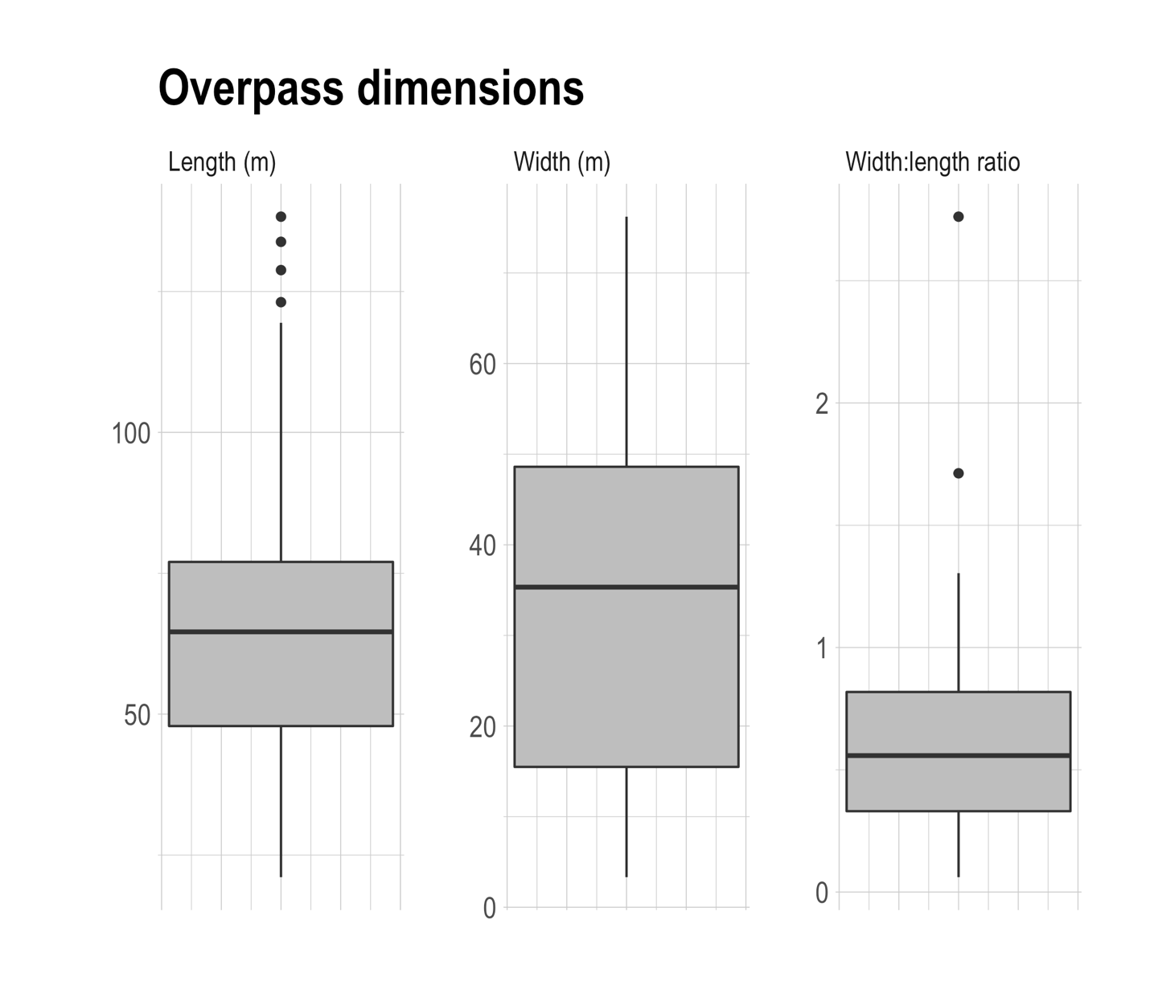

**Figure 4.** Dimensions of 120 wildlife overpasses from around the world included in the review. All overpass measurements performed using the ruler tool in Google Earth Pro 7.3.4.8573 (64-bit). We define width as the estimated inner width of overpass and length as the estimated headwall length of overpass structures .

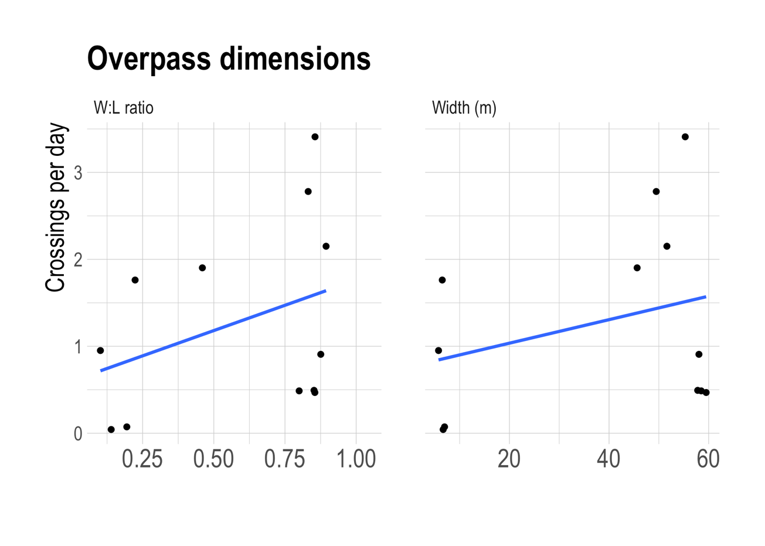

**Figure 5:** Overpass inner width in relation to the number of successful wildlife crossings per day. Data compiled from transportation agencies and government reports. Species included in analysis: (black bears (*Ursus americanus),* grizzly bears *(Ursus arctos),*wolves *(Canis lupus)*, coyote *(Canis latrans),* cougars *(Puma concolor),* deer *(Odocoileus sp.)*, elk *(Cervus elaphus)*, moose (*Alces alces) and,* Bighorn Sheep *(Ovis canadensis)* crossing rates and the width of 12 overpasses located in western North America. See Appendix A Table A.7 for details.

**4.0 Discussion**

**4.1 Distribution of Wildlife Overpasses**

Our review found wildlife overpasses constructed in many countries across the world over the past forty years. In total, we identified 120 structures located in North America, Europe, southeast Asia, South America and Australia. We found few records of overpasses in many of the worlds’ most abundant areas of large mammals such as southern Africa and South America, although a single structure existed in Argentina. The overpasses were generally built to allow for safe passage of various wildlife species and to restore habitat connectivity. Interestingly, we found high concentrations of wildlife overpasses in areas of high road and human density such as South Korea and Holland. Where habitat fragmentation has caused significant wildlife and biodiversity declines, (e.g. Western Europe and parts of Asia) local governments have responded by investing in landscape connectivity programs that include crossing structures such as wildlife overpasses (Sijtsma et al. 2020; Woo et al.,2018) Many overpasses was also identified in western North America that were built to support the diverse assemblage of large bodied mammals such as grizzly bear, moose, and elk, in the region.

**4.2 Overpass widths**

Of the overpasses for which Pimm et al. (2021) were able to find supporting dimensions information (n=82), they found that nearly half of the overpasses were greater than 50m wide. In contrast, we found only 20% of the overpasses included in our review (n=96), were wider than 50m. We suspect the discrepancy of results is due to two main factors. To allow for comparison to relevant guidelines we excluded any overpasses that were >80 m wide (classified as a landscape bridge (Iuell, B. (ed.). 2003), reducing the percent of the overpass structures that are >50m wide. Secondly, we found that Google Earth Pro measurements of the inner width of the structures for which we had sufficient supporting information (n=24) were 7% less than those reported in the literature. With very few mentions of overpass dimensional definitions in the literature, we suspect transportation professionals often report what we have defined as the outer width of the structure, possibly explaining the Pimmet al.(2021) results. Especially where wildlife overpasses often incorporate elements such as fencing and earthen berms to limit acoustic impacts of the road (Solowczuk, 2020), a clear definition of overpass width is needed. As suggested here, and by Iuell, B. (ed.), (2003)the inner width of the overpass is most representative of the width available to animals as they cross the structure, and should be the default width measurement used by transportation agencies. Universal definitions of both overpass width and length will help to ensure that future wildlife overpasses meet expert recommendations and fulfill the ecological role for which they are designed.

**4.3 Adherence to expert-based recommendations**

Comparing the built dimensions of overpasses to expert recommendations, we found that wildlife overpasses were generally built narrower than standards recommended by experts. The goal of dimensional standards, outlined by Clevenger & Huijser (2011) and Iuell et al. (2003) are to facilitate overpass designs that are effective in achieving sufficient crossings of target species and to provide adequate conservation return on infrastructure investments. Notably, 71% of North American overpasses were in non-compliance with the >50m wide recommendation (Clevenger & Huijser, 2011). Likewise, 50% of European overpasses failed to meet the respective >40m recommendation (Iuell, B. (ed.), 2003). In stark contrast, compared to their respective expert guidelines, Woo et al. (2018) found a 14% rate of non-compliance of overpass widths in South Korea. In both North America and Europe, the non-compliance of overpass width may partially be explained by the specific targeting of certain ungulate species such as deer which are less sensitive to more narrow overpasses (Iuell, B. (ed.), 2003).

Notably, 79% of the European structures in this review did not meet the recommended minimum 0.8 width: length ratio established by the European Transportation Agency (Iuell, B. (ed.). 2003). The width length ratio recommendation is often less prominent, or absent, in both the peer reviewed literature and transportation handbooks on overpass dimension recommendations. As such, the focus on width as a static quantity, rather than a dimension that needs to be considered in concert with length, may be poorly communicated to transportation professionals in the current literature. Future projects should consider that longer overpasses must also be wider to facilitate animal passage.

**4.4 Effectiveness**

The overpass width effectiveness analysis produced a positive but insignificant relationship between overpass width, width:length, and the total number of large bodied mammals, ungulates, carnivore or species-specific crossings per day. This was not altogether surprising given the limited sample size (n=12), and our inability to control for local wildlife densities. Nevertheless, it was qualitatively observed that wider North American overpasses (40–60 m), in or near compliance with expert guidelines, were associated with a more diverse set of species use and had higher average crossing rates when compared to non-compliant, narrow North American overpasses. These findings support evidence that suggests wider crossings structures favour the passage of a wider array of taxa (Clevenger & Huijser, 2011), and also support the recommendations of Rytwiniski et al., (2015) that more rigorous experimental study designs to monitor the effectiveness of strucutrs would help guide future investments in wildlife crossing infrastructure.

Further, a species-specific response to crossing structure parameters such as width is well established (Mata et al., 2008; Sawyer et al., 2016). We therefore would not expect meaningful results when assessing the width response of large taxonomic groups such as ungulates or carnivores. Researchers have in fact, shown conflicting crossing structures width responses in ungulate species such as big-horned sheep, deer, elk and pronghorn (Clevenger & Waltho, 2005; Gagnon et al., 2017; Sawyer et al., 2016). A recent study by Dennebom et al. (2021), fails to consider the unique species-specific response to overpass width and wrongfully concludes that ungulates prefer narrow overpasses. When assessing wildlife crossings structure parameters future studies should investigate species-species responses rather than taxa wide responses.

Scientists and transportation professionals should strive to develop a standardized measure of structure effectiveness to inform future investment in crossing structures (as pointed out by Rytwiniski et al., 2015 and van der Grift et al., 2012). Such investment is likely to increase. For example, in July 2021, the U.S.A. passed the INVEST in America Act, a five-year highway bill that includes $100 million per year for crossing structures. To guide these future investments, a standardized procedure for measuring crossing effectiveness should be developed that can overcome differing ecological conditions between structures and projects that hamper comparisons. One option that is easily integrated into current monitoring programs with remote cameras is to include remote cameras on wildlife trails a few hundred meters away from the structure. With this design, investigators can get a sense of species detection rates between cameras on the structure and those nearby, allowing for a transparent measure of effectiveness that can be compared to hit rates of species nearby. A similar design has been previously suggested by Rytwiniski et al. (2015) as part of their plea for increased use of rigorous study designs, such as before-after-control-impact designs, for evaluating road mitigation effectiveness. For example, a structure that has ten elk detections per week and 100 elk detections per week nearby on wildlife trails (i.e., 10:100, or 0.1) would be less effective than a structure that had 80 elk detections per week on the structure and 110 elk detections per week nearby on wildlife trails (i.e., 80:110, or 0.72). When available, incorporating other forms of biological data (e.g. demographic data) can help to further determine if the overpass provides demographic and population wide connectivity (Ford et al., 2017). In Banff National Park, overpass effectiveness in terms of gene flow has been successfully demonstrated using genetic data for black bears and grizzly bears (Sawaya et al., 2014).

**4.5 Cost effectiveness**

In the Netherlands, Sijtsma et al. (2020) found that overpasses present a less cost-effective solution than underpasses. They argue that the high construction costs of overpasses outweigh their absolute benefit to local biodiversity, making underpasses a more cost-effective solution. The authors, however, concede that their threat-weighted ecological quality cost-effectiveness analysis fails to differentiate between “different species and nature types”. As a result, in places with more diverse and abundant assemblages of large mammals or with width-sensitive species, overpasses may become more cost effective. Indeed, Ford et al. (2017) performed a cost-effectiveness analysis of grizzly bear crossings at five crossing structure types in Banff National Park, Canada. Using a demographic-specific cost-effectiveness economic model, they found that especially amongst family units, overpasses are more cost effective than underpasses. Amongst singleton bears, the cost effectiveness of overpasses and underpasses were similar. The costs for underpasses used in Ford et al. (2017) included the assumption that the highway was under construction at the time, thus representing a lower cost than if the underpass as added to an existing highway, as is the case for many places mitigation is being considered. The findings between the two studies illustrate how the results of cost-effectiveness analysis may vary at different scales of study, target species assemblage, and stage of highway construction.

Cost is likely the main constraint limiting transportation agency’s ability to meet expert recommendations for overpass dimensions. A wildlife crossing project being developed along Highway 3 in the southern Rocky Mountains of Canada provides a case-study where transportation professionals, scientists, conservation organizations, industry partners, and First Nations are working to create a cost-effective design in a working landscape. The “Reconnecting the Rockies: BC” project is focused along a 27 km stretch of Highway 3 in southeastern BC, where movement corridors for deer, elk, sheep, moose, bear, wolf, wolverine, and cougar all intersect with a busy highway. The project will feature two purpose-built underpasses, six retrofitted bridges to allow wildlife passage, and an overpass located in the critical Alexander-Michel corridor will be a main feature of the project. The overpass will be the most expensive aspect of the project and multiple designs have been proposed and analyzed for cost. The overpass will span a length of 75 m across two lanes of road and a railway line. The preferred overpass design, which was costed in 2020 for three different widths, 40 m, 50 m, and 70 m wide, would respectively cost an estimated $6.2, $7.3, and $9.7 million. Although there is some efficiency of scale as widths increase—with the cost per meter of width decreasing from $0.155 million per meter for the 40 m structure, to $0.139 million per meter for the 70 m structure, the overall increase in price as overpass width increases means that compromises need to be made to accommodate the restricted budget available for this project. While construction has not yet started on this structure, the collaborative group is currently finishing the design phase of the project and favours the 50 m wide structure, which meets the expert recommendations for the target species (a diverse assemblage of large mammals), incorporates some savings with scale, but falls in the middle ground for price option available. The Reconnecting the Rockies example highlights the real-world trade-offs that are required, and the tension between increasing costs and structure effectiveness, which can be optimized through pairing expert design recommendations and innovative engineering support.

**4.6 The application of the Single Large or Several Small (SLOSS) debate to Road Ecology**  
Few studies have addressed the Single Large or Several Small (SLOSS) argument as it pertains to wildlife crossings structures and overpasses (Helldin, 2022). With the evidence accumulated in this review, we conclude that some species, under certain circumstances, will use more mid-sized overpass structures (~30 m wide), that fall below many expert recommendations. As a result, a key question comes to mind: could two 30m overpasses be more effective than a single 60 m overpass? In the face of the SLOSS decision-point, the optimal solution will ultimately rely upon multiple factors. If we assume the cost of the two options are equivalent, the crossings structures target the mitigation of narrow tolerant ungulates (e.g. roe deer) (Iuell, B. (ed.), 2003) and adjacent habitat quality cannot be controlled, then the two more narrow overpasses may present a favourable risk diversification scenario (Helldin, 2022). Two overpasses will increase the likelihood that wildlife will have access to an overpass with favourable characteristics and that is surrounded by high quality habitat. In contrast, a single very wide overpass is likely favourable in scenarios were adjacent land use is well managed and the structure targets the passage of width-sensitive specific species or a diverse assemblage of species (Helldin, 2022). In their demographic-specific cost-effectiveness economic model, Ford et al. (2017) find cost-effectiveness on both sides of the SLOSS debate. Both large overpasses (favourable for passing family units) and a diversity of several smaller underpasses (favourable for minimizing bottleneck and intraspecific predation effects) showed favourable connectivity effects on grizzly bears in Banff National Park. Nevertheless, it remains clear that single small overpasses, or few underpasses are not recommended solutions to support crossings, and that agencies should target designs at either end of the SLOSS debate depending on the topography and species available.

**4.7 Conclusions**

Our review finds that transportation agencies are often building structures below expert design recommendations. We suspect the high costs of wide overpasses are a key factor in explaining the high rates of non-compliance of overpasses in Europe and North America. The lack of universal dimensional definitions and poor communication of certain guidelines (i.e., width to length ratios) has likely also contributed to instances of overpass non-compliance. Importantly, we recommend guidelines also be updated regularly to ensure they accurately reflect the best available science. Despite a history of non-compliance to the specific guideline in Europe, the width of overpasses around the world should scale accordingly with their length. More rigorous wildlife overpass effectiveness analysis will require better experimental design (e.g. BACI) and more supporting overpass parameter data that what was included in our review. We conclude that wide overpasses (~50m) continue to present important, cost effective solutions in decreasing the barrier effective of the road (especially when targeting width sensitive species and large assemblages of mammals) but encourage future studies to further explore the specific instances when underpasses and narrower overpasses present more cost-effective solutions.

**Acknowledgements**

We thank T. Clevenger for their comments which greatly improved this manuscript. Clayton Lamb was supported by the Liber Ero Fellowship while conducting this work.

**Funding:** This research did not receive any specific grant from funding agencies in the public, commercial, or not-for-profit sectors.

**Literature Cited**

Barrueto, M., Ford, A. T., & Clevenger, A. P. (2014). Anthropogenic effects on activity patterns of wildlife at crossing structures. *Ecosphere*, *5*(3), art27. <https://doi.org/10.1890/ES13-00382.1>

Clevenger, A. P. (2005). Conservation Value of Wildlife Crossings: Measures of Performance and Research Directions. *GAIA - Ecological Perspectives for Science and Society*, *14*(2), 124–129. <https://doi.org/10.14512/gaia.14.2.12>

Clevenger, A. P., & Huijser, M. P. (2011). *Wildlife Crossing Structure Handbook Design and Evaluation in North America* (Final Report FHWA-CFL/TD-11-003; p. 224). Western Transportation Institute.

Clevenger, A. P., & Waltho, N. (2000). Factors Influencing the Effectiveness of Wildlife Underpasses in Banff National Park, Alberta, Canada. *Conservation Biology*, *14*(1), 47–56.

Clevenger, A. P., & Waltho, N. (2005). Performance indices to identify attributes of highway crossing structures facilitating movement of large mammals. *Biological Conservation*, *121*(3), 453–464. <https://doi.org/10.1016/j.biocon.2004.04.025>

Corlatti, L., Hackländer, K., & Frey-Roos, F. (2009). Ability of Wildlife Overpasses to Provide Connectivity and Prevent Genetic Isolation. *Conservation Biology*, *23*(3), 548–556. <https://doi.org/10.1111/j.1523-1739.2008.01162.x>

Cramer, P. (2012). *Determining Wildlife Use of Wildlife Crossing Structures Under Different Scenarios* (UT-12.07; p. 181). Utah Department of Transportation. [www.udot.utah.gov/go/research](https://doi.org/www.udot.utah.gov/go/research)

Denneboom, D., Bar-Massada, A., & Shwartz, A. (2021). Factors affecting usage of crossing structures by wildlife – A systematic review and meta-analysis. *Science of The Total Environment*, *777*, 146061. <https://doi.org/10.1016/j.scitotenv.2021.146061>

Fahrig, L., & Rytwinski, T. (2009). Effects of Roads on Animal Abundance: An Empirical Review and Synthesis. *Ecology and Society*, *14*(1), art21. <https://doi.org/10.5751/ES-02815-140121>

Ford, A. T., Barrueto, M., & Clevenger, A. P. (2017). Road mitigation is a demographic filter for grizzly bears: Road Crossing Behavior in Grizzly Bears. *Wildlife Society Bulletin*, *41*(4), 712–719. <https://doi.org/10.1002/wsb.828>

Forman, R. T. T., & Alexander, L. E. (1998). Roads their Major Ecological Effects. *Annual Review of Ecology and Systematics*, *29*(1), 207–231. <https://doi.org/10.1146/annurev.ecolsys.29.1.207>

Gagnon, J., Loberger, C., Ogren, K., Sprague, S., & Boe, S. (2017). *Evaluation of Desert Bighorn Sheep Overpass Effectiveness: U.S. Route 93 Long-Term Monitoring* (Final Report FHWA-AZ-17-710; p. 87). Arizona Department of Transportation.

Gloyne, C. C., & Clevenger, A. P. (2001). Cougar *Puma concolor* use of wildlife crossing structures on the Trans‐Canada highway in Banff National Park, Alberta. *Wildlife Biology*, *7*(2), 117–124. <https://doi.org/10.2981/wlb.2001.009>

Gunson, K. E., Clevenger, A. P., & Hall, C. (2003). Large Animal-Vehicle Collisions in the Central Canadian Rocky Mountains: Patterns and Characteristics. *In Proceedings of the 2003 International Conference on Ecology and Transportation. Making Connections*. NC: Center for Transportation and the Environment.

Harrington, S., Teitelman, J., Rummel, E., Morse, B., Chen, P., Eisentraut, D., & McDonough, D. (2017). Validating Google Earth Pro as a Scientific Utility for Use in Accident Reconstruction. *SAE International Journal of Transportation Safety*, *5*(2), 135–166. <https://doi.org/10.4271/2017-01-9750>

Helldin, J. O. (2022). Are several small wildlife crossing structures better than a single large? Arguments from the perspective of large wildlife conservation. *Nature Conservation*, *47*, 197–213. <https://doi.org/10.3897/natureconservation.47.67979>

Huijser, M. P., Camel-Means, W., Fairbank, E. R., Purdum, J. P., Allen, T. D. H., Hardy, A. R., Graham, J., Begley, J. S., & Basting, P. (2016). *US 93 North Post-Construction Wildlife-Vehicle Collision and Wildlife Crossing Monitoring on the Flathead Indian Reservation between Evaro and Polson, Montana Final Report*. 159.

Huijser, M. P., Duffield, J. W., Clevenger, A. P., Ament, R. J., & McGowen, P. T. (2009). Cost-Benefit Analyses of Mitigation Measures Aimed at Reducing Collisions with Large Ungulates in the United States and Canada: A Decision Support Tool. *Ecology and Society*, *14*(2), art15. <https://doi.org/10.5751/ES-03000-140215>

Huijser, M. P., Fairbank, E. R., Camel-Means, W., Graham, J., Watson, V., Basting, P., & Becker, D. (2016). Effectiveness of short sections of wildlife fencing and crossing structures along highways in reducing wildlife–vehicle collisions and providing safe crossing opportunities for large mammals. *Biological Conservation*, *197*, 61–68. <https://doi.org/10.1016/j.biocon.2016.02.002>

Iuell, B., Bekker, H., Cuperus, R., Dufek, J., Fry, G., Hicks, C., Hlavac, V., Keller, V., Rosell, C., Sangwine, T., Torslov, N., & Wandall, B. le M. (2003). *COST 341 Habitat Fragmentation due to Transportation Infrastructure. Wildlife and Traffic: A European Handbook for Identifying Conflicts and Designing Solutions* (p. 172). European Co-operation in the Field of Scientific and Technical Research.

Kusak, J., Huber, D., & Frkovic, A. (2000). The effects of traffic on large carnivore populations in Croatia. *Biosphere Conservation*, *3*(1), 35–39.

Kusak, J., Huber, D., Gomerčić, T., Schwaderer, G., & Gužvica, G. (2009). The permeability of highway in Gorski kotar (Croatia) for large mammals. *European Journal of Wildlife Research*, *55*(1), 7–21. <https://doi.org/10.1007/s10344-008-0208-5>

Mata, C., Hervás, I., Herranz, J., Suárez, F., & Malo, J. E. (2008). Are motorway wildlife passages worth building? Vertebrate use of road-crossing structures on a Spanish motorway. *Journal of Environmental Management*, *88*(3), 407–415. <https://doi.org/10.1016/j.jenvman.2007.03.014>

McGuire, T., and J. Morrall. 2000. Strategic highway improvements to minimize environmental impacts within the Canadian Rocky Mountain national parks. Canadian Journal of Civil Engineering 27:523–532.

McKinney, T., & Smith, T. (2007). US93 Bighorn Sheep Study: Distribution and Trans-Highway Movements of Desert Bighorn Sheep in Northwestern Arizona (Final Report FHWA-AZ-07-576; p. 66). Arizona Department of Transportation.

Pimm, S. L., Willigan, E., Kolarova, A., & Huang, R. (2021). Reconnecting nature. *Current Biology*, *31*(19), R1159–R1164. <https://doi.org/10.1016/j.cub.2021.07.040>

Riley, S. P. D., Pollinger, J. P., Sauvajot, R. M., York, E. C., Bromley, C., Fuller, T. K., & Wayne, R. K. (2006). A southern California freeway is a physical and social barrier to gene flow in carnivores: Physical and Social Barrier to Gene Flow. *Molecular Ecology*, *15*(7), 1733–1741. <https://doi.org/10.1111/j.1365-294X.2006.02907.x>

Rytwinski, T., Soanes, K., Jaeger, J. A. G., Fahrig, L., Findlay, C. S., Houlahan, J., van der Ree, R., & van der Grift, E. A. (2016). How Effective Is Road Mitigation at Reducing Road-Kill? A Meta-Analysis. *PLOS ONE*, *11*(11), e0166941. <https://doi.org/10.1371/journal.pone.0166941>

Rytwinski, T., van der Ree, R., Cunnington, G. M., Fahrig, L., Findlay, C. S., Houlahan, J., Jaeger, J. A. G., Soanes, K., & van der Grift, E. A. (2015). Experimental study designs to improve the evaluation of road mitigation measures for wildlife. *Journal of Environmental Management*, *154*, 48–64. <https://doi.org/10.1016/j.jenvman.2015.01.048>

Sawaya, M. A., Clevenger, A. P., & Kalinowski, S. T. (2013). Demographic Connectivity for Ursid Populations at Wildlife Crossing Structures in Banff National Park: Wildlife Crossing Structures. *Conservation Biology*, *27*(4), 721–730. <https://doi.org/10.1111/cobi.12075>

Sawaya, M. A., Clevenger, A. P., & Schwartz, M. K. (2019). Demographic fragmentation of a protected wolverine population bisected by a major transportation corridor. *Biological Conservation*, *236*, 616–625. <https://doi.org/10.1016/j.biocon.2019.06.030>

Sawaya, M. A., Kalinowski, S. T., & Clevenger, A. P. (2014). Genetic connectivity for two bear species at wildlife crossing structures in Banff National Park. *Proceedings of the Royal Society B: Biological Sciences*, *281*(1780), 20131705. <https://doi.org/10.1098/rspb.2013.1705>

Sawyer, H., Rodgers, P. A., & Hart, T. (2016). Pronghorn and mule deer use of underpasses and overpasses along U.S. Highway 191: Overpass and Underpass Use by Pronghorn and Mule Deer. *Wildlife Society Bulletin*, *40*(2), 211–216. <https://doi.org/10.1002/wsb.650>

Seo, H., Choi, C., Lee, K., & Woo, D. (2021). Landscape Characteristics Based on Effectiveness of Wildlife Crossing Structures in South Korea. *Sustainability*, *13*(2), 675. <https://doi.org/10.3390/su13020675>

Sielecki, L. (2007). The Evolution of Wildlife Exclusion System on Highways in British Columbia. *Proceedings of the 2007 International Conference on Ecology and Transportation, edited by C. Leroy Irwin, Debra Nelson, and K.P. McDermott. Raleigh*. NC: Center for Transportation and the Environment.

Sijtsma, F. J., van der Veen, E., van Hinsberg, A., Pouwels, R., Bekker, R., van Dijk, R. E., Grutters, M., Klaassen, R., Krijn, M., Mouissie, M., & Wymenga, E. (2020). Ecological impact and cost-effectiveness of wildlife crossings in a highly fragmented landscape: A multi-method approach. *Landscape Ecology*, *35*(7), 1701–1720. <https://doi.org/10.1007/s10980-020-01047-z>

Simpson, N. O., Stewart, K. M., Schroeder, C., Cox, M., Huebner, K., & Wasley, T. (2016). Overpasses and underpasses: Effectiveness of crossing structures for migratory ungulates: Crossing Structures and Migratory Ungulates. *The Journal of Wildlife Management*, *80*(8), 1370–1378. <https://doi.org/10.1002/jwmg.21132>

Sołowczuk, A. (2020). Effect of Landscape Elements and Structures on the Acoustic Environment on Wildlife Overpasses Located in Rural Areas. *Sustainability*, *12*(19), 7866. <https://doi.org/10.3390/su12197866>

Trombulak, S. C., & Frissell, C. A. (2000). Review of Ecological Effects of Roads on Terrestrial and Aquatic Communities. *Conservation Biology*, *14*(1), 18–30. <https://doi.org/10.1046/j.1523-1739.2000.99084.x>

van der Grift, E. A., van der Ree, R., Fahrig, L., Findlay, S., Houlahan, J., Jaeger, J. A. G., Klar, N., Madriñan, L. F., & Olson, L. (2013). Evaluating the effectiveness of road mitigation measures. *Biodiversity and Conservation*, *22*(2), 425–448. <https://doi.org/10.1007/s10531-012-0421-0>

van der Ree, R., Heinze, D., McCarthy, M., & Mansergh, I. (2009). Wildlife Tunnel Enhances Population Viability. *Ecology and Society*, *14*(2), art7. <https://doi.org/10.5751/ES-02957-140207>

van der Ree, Rodney & van der Grift, Edgar & Gulle, Nadine & Holland, Kelly & Mata Estacio, Cristina & Suarez, Francisco. (2007). Overcoming the barrier effect of roads - How effective are mitigation strategies? An international review of the effectiveness of underpasses and overpasses designed to increase the permeability of roads for wildlife. *Proceedings in the International Conference on Ecology and Transportation.*

Woo, D., Park, H., Seo, H.-S., Moon, H.-G., Song, E., Lim, A., & Choi, T.-Y. (2018). Assessing Compliance with the Wildlife Crossing Guideline in South Korea. *Journal of Forest and Environmental Science*, *34*(2), 176–179. <https://doi.org/10.7747/JFES.2018.34.2.176>

**APPENDIX A**

**Table A.1:** Parameters of the 120 wildlife overpasses included in review. Min and max shown in brackets.

|  |  |
| --- | --- |
| **Mean Reported Width1 (n = 24)** | 38 m (6-60) |
| **Mean Inner Width 2,3 (n=97)** | 34 m (3-76) |
| **Mean Outer Width2,4 (n=97)** | 39 m (5-99) |
| **Mean Reported Length1 (n=18)** | 51 m (20-67) |
| **Mean Roadway Width (measure of length of OP)2,5 (n=107)** | 32 m (6-113) |
| **Mean Overpass Headwall Length2 (n=90)** | 65 m (21-138) |
| **Mean Overpass Length including approach ramps2,7 (n=27)** | 103 m (39-255) |
| **Mean reported W:L1 (n=18)** | 0.75 (0.11-1.52) |
| **Mean estimated W: L2,8 (n=90)** | 0.58 (0.06-2.76) |
| **Mean Overpass Age (n =79)** | 16 years (3-47) |
| **Mean number of lanes of traffic crossed (n=110)** | 4 (2-8) |

1. *Dimensions found in relevant literature and grey literature*
2. *Dimensions estimated in Google Earth Pro 7.3.4.8573 (64-bit).*
3. *Inner width: the measure of usable surface of the overpass, defined as the inside extent of headwalls or fences as visible from aerial imagery in Google Earth Pro 7.3.4.8573 (64-bit)..*
4. *Outer width: the measure of the lateral extent of the structure including the outermost extent of headwall or fences as visible from aerial imagery in Google Earth Pro 7.3.4.8573 (64-bit)..*
5. *Road width: a measure of the length of the overpass above, defined as the outermost extent of asphalt as visible from aerial imagery in Google Earth Pro 7.3.4.8573 (64-bit).*
6. *Headwall length: a measure of the extent of overpass headwall across the roadway below, in Google Earth Pro 7.3.4.8573 (64-bit).*
7. *Overpass and ramps length: the entire extent of human altered landscape, including earthen ramps (only recorded if visible)*
8. *W:L: width to length ratios using the inner width and headwall length of an overpass*

**Table A.2: North American Overpass Parameters Reported in Literature**

|  |  |  |  |
| --- | --- | --- | --- |
|  | **Global Wildlife Overpass Parameters** | **Expert Recommendations 3** | **Compliance** |
| **Mean Reported Width (n=20)** | 37 m (6-60) | >50 m | 40% |
| **Mean Reported Length (n=18)** | 51 m (20-67) | - | - |
| **Mean W:L Ratio (n=18)** | 0.75 (0.11-1.52) | - | - |
| **Mean Overpass Age (n=29)** | 15 years (3-47) | - | - |

**Table A.3: North American Parameters Estimated in Google Earth**

|  |  |  |  |
| --- | --- | --- | --- |
| **Mean Width (n=28)1** | 33 m (6-65) | >50 m | 29% |
| **Mean Length (n=27)2** | 62 m (29-109) | - | - |
| **Mean W:L Ratio (n=27)** | 0.53 (0.09-1.10) | - | - |
| **Mean Roadway Width (n=28)** | 33 m (10-62) | - | - |
| **Mean Number of Traffic Lanes Crossed (n=28)** | 4 (2-8) | - | - |

1. *Estimated inner width of overpass using Google Earth Pro 7.3.4.8573 (64-bit).*
2. *Estimated headwall length of overpass structures using Google Earth Pro 7.3.4.8573 (64-bit).*
3. *Expert width recommendation of 50m or greater for overpasses in North American (*Clevenger and Huijser*,* 2011)

**Table A.4: European Overpass Parameters Reported in Literature**

|  |  |  |  |
| --- | --- | --- | --- |
|  | **Global Wildlife Overpass Parameters** | **Expert Recommendations 3,4** | **Compliance** |
| **Mean Reported Width (n=2)** | 50m | >40 m | 100% |
| **Mean Reported Length (n=0)** | - | - | - |
| **Mean W:L Ratio (n=0)** | - | >0.8 m | - |
| **Mean Overpass Age (n=14)** | 19 years (5-46) | - | - |

**Table A.5: European Parameters Estimated in Google Earth**

|  |  |  |  |
| --- | --- | --- | --- |
|  | **Global Wildlife Overpass Parameters** | **Expert Recommendations 3,4** | **Compliance** |
| **Mean Width (n=52)1** | 38m (11-76) | >40 m | 50% |
| **Mean Length (n=52)2** | 72 m (23-138) | - | - |
| **Mean W:L Ratio (n=52)** | 0.60 (0.13-2.76) | >0.8 | 21% |
| **Mean Roadway Width (n=51)** | 37 m (8-113) | - | - |
| **Mean Number of Traffic Lanes Crossed (n=51)** | 4 (2-8) | - | - |

1. *Estimated inner width of overpass using Google Earth Pro 7.3.4.8573 (64-bit).*
2. *Estimated headwall length of overpass structures using Google Earth Pro 7.3.4.8573 (64-bit).*
3. *Expert width recommendation of 40m or greater for overpasses in Europe (Iuell, B. (ed.). 2003).*
4. *Expert W:L recommendations of 0.8 or greater for overpasses in Europe (Iuell, B. (ed.). 2003).*

**Table A.6 :** Assessment of dimensional guideline compliance for various structures with information gathered from both Google Earth and the Literature for structures with supporting information in the literature

|  |  |
| --- | --- |
|  | **Global Wildlife Overpass Parameters** |
| **Mean Reported Width (n = 24)** | 39 m (6-60) |
| **Mean Inner Width 1**  **(n= 24)** | 36 m (6-60) |
| **Mean Outer Width,4 (n=24)** | 40 m (7-66) |

1. *Estimated inner width of overpass measured with Google Earth Pro 7.3.4.8573 (64-bit).*
2. *Outer width: the measure of the lateral extent of the structure including the outermost extent of headwall or fences as visible from aerial imagery in Google Earth Pro 7.3.4.8573 (64-bit).*

**Table A.7:** Supporting information for 12 overpass structures included in overpass effectiveness analysis. Species included in analysis: (black bears (*Ursus americanus),* grizzly bears *(Ursus arctos),*wolves *(Canis lupus)*, coyote *(Canis latrans),* cougars *(Puma concolor),* deer *(Odocoileus sp.)*, elk *(Cervus elaphus)*, moose (*Alces alces) and,* Bighorn Sheep *(Ovis canadensis)* crossing rates and the width of 12 overpasses located in western North America..

|  |  |  |  |  |  |  |  |  |  |  |  |
| --- | --- | --- | --- | --- | --- | --- | --- | --- | --- | --- | --- |
| Name | Country | Province/State | Year of build_clean | Width | Length | Width: Length | Number of Monitoring Days | Period of Monitoring | Total Number of Large Mammal Crossings Per Day | Number of large bodied mammal species reported to use (/9) | Source |
| Banff National Park Wolverine Overpass | Canada | Alberta | 1996 | 51.62 | 57.72 | 0.89431739 | 3180 | 2006-2014 | 2.15062893 | 8 | Parks Canada? |
| Banff National Park Red Earth Overpass | Canada | Alberta | 1996 | 49.48 | 59.51 | 0.8314569 | 3180 | 2007-2015 | 2.78050314 | 8 |  |
| Banff National Park Temple Overpass | Canada | Alberta | 2010 | 58.51 | 73.16 | 0.79975396 | 1486 | 2011-2015 | 0.487214 | 7 |  |
| Banff National Park Lake Louise Over Pass | Canada | Alberta | 2009 | 59.5 | 69.6 | 0.85488506 | 1471 | 2010-2015 | 0.46838885 | 7 |  |
| Banff National Park Castle Overpass | Canada | Alberta | 2011 | 58.05 | 66.29 | 0.87569769 | 1190 | 2011-2015 | 0.90756303 | 8 | (Clevenger & Waltho, 2005), (Ford et al., 2017) |
| Banff National Park Panorama Overpass | Canada | Alberta | 2011 | 57.8 | 67.84 | 0.85200472 | 1203 | 2011-2015 | 0.49293433 | 7 |  |
| Trepanier Creek | Canada | British Columbia | 1990 | 5.76 | 56.63 | 0.10171287 | 164 | November 27th 2017 to May 10th 2018 | 0.95121951 | 3 | (BC MOTI, 2021) |
| Glenogle | Canada | British Columbia | 2011 | 6.69 | 47.94 | 0.13954944 | 164 | November 27th 2017 to May 10th 2018 | 0.04268293 | 1 | (BC MOTI, 2021) |
| Golden Hill | Canada | British Columbia | 2011 | 6.51 | 29.12 | 0.22355769 | 164 | November 27th 2017 to May 10th 2019 | 1.76219512 | 5 | (BC MOTI, 2021) |
| Palliser | Canada | British Columbia | 2011 | 6.97 | 35.86 | 0.19436698 | 164 | November 27th 2017 to May 10th 2020 | 0.07317073 | 3 | (BC MOTI, 2021) |
| Highway 93 North | U.S.A | Montana | 2013 | 55.3 | 64.64 | 0.64510347 | 1826 | 1 January 2011 to 31 December 2015 | 3.40963855 | 6 | (Huijser  *et al.,* 2016) |
| Washington OP | U.S.A | Washington | 2018 | 45.64 | 99.26 | 0.45980254 | 1139 | November 2018 to December 2021 | 1.90254609 | 3 |  |

**Table A.8?**

|  |  |  |  |  |
| --- | --- | --- | --- | --- |
| **Assemblage of Species** | **Overpass Width** | **Positive/Negative** | **Overpass W:L** | **Positive/Negative** |
| **Total** |  |  |  |  |
| **Ungulates** |  |  |  |  |
| **Carnivores** |  |  |  |  |
| **Deer** |  |  |  |  |
| **Elk** |  |  |  |  |
| **Moose** |  |  |  |  |
| **Black Bear** |  |  |  |  |
| **Grizzly Bear** |  |  |  |  |
| **Cougar** |  |  |  |  |
| **Bighorn Sheep** |  |  |  |  |
| **Wolf** |  |  |  |  |
| **Coyote** |  |  |  |  |

**Appendix B**

**Table B.1:** Test measurements from professional or collegiate football stadiums across the continental U.S.A. to determine relative error of measurements made using the ruler tool in Google Earth Pro 7.3.4.8573 (64-bit).

|  |  |  |
| --- | --- | --- |
| **Stadium Name** | **Location** | **Length(m) measured using Google Earth path tool** |
| Empower Field at Mile High | Denver, CO | 91.8 |
| FedExField | Landover, Maryland | 91.7 |
| FirstEnergy Stadium | Cleveland, OH | 91.5 |
| Heinz Field | Pittsburgh, PA | 91.6 |
| Highmark Stadium | Orchard Park, New York | 91.6 |
| Levi's Stadium | Santa Clara, CA | 91.5 |
| Lumen Field | Seattle, WA | 91.3 |
| MetLife Stadium | East Rutherford, NJ | 92.4 |
| Paul Brown Stadium | Cincinnati, OH | 91.5 |
| Raymond James Stadium | Tampa, FL | 91.6 |
| Soldier Field | Chicago, IL | 91.7 |
| TIAA Bank Field | Jacksonville, FL | 91.7 |
| 3MG Stadium | Orlando, FL | 91.5 |
| Aggie Memorial Stadium | Las Cruces, NM | 91.4 |
| Alaska Airlines Field at Husky Stadium | Seattle, WA | 91.8 |
| Albertsons Stadium | Boise, ID | 90.9 |
| Allen E. Paulson Stadium | Statesboro, GA | 91.6 |
| Alumni Stadium | Chesnut Hill, MA | 91.5 |
| Amon G. Carter Stadium | Fort Worth, TX | 91.7 |
| Apogee Stadium | Denton, TX | 91.8 |

**Equation E.1:** Relative error of Google Earth Pro 7.3.4.8573 (64-bit) ruler tool

**Calculations**

**%Error**

= ((sum of measurements / n)-true value) / true value)*100%

= ((91.61-91.44)/91.44) *100%1

=0.2%

1. 91.44 = length of American football field